Session 08 – Event Logs Wei Cui

Step 8. Select a specific event and then double-click it to display detailed information on the event. When finished, click Close and the back arrow to return to the Overview and Summary Page.

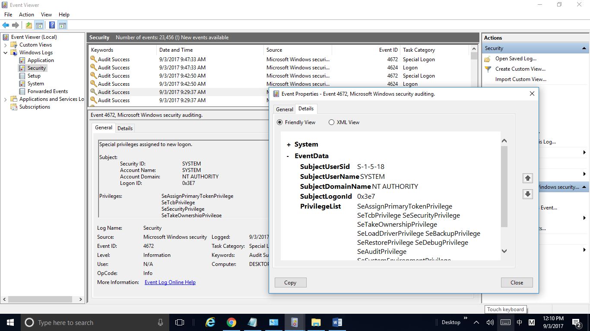

Fig. 1. Screenshot of Detailed Information of Event 4672 in Event Viewer(Step 8). 1. Double click Security, 2. Double click a specifc event, and 3. The detail information on the event.

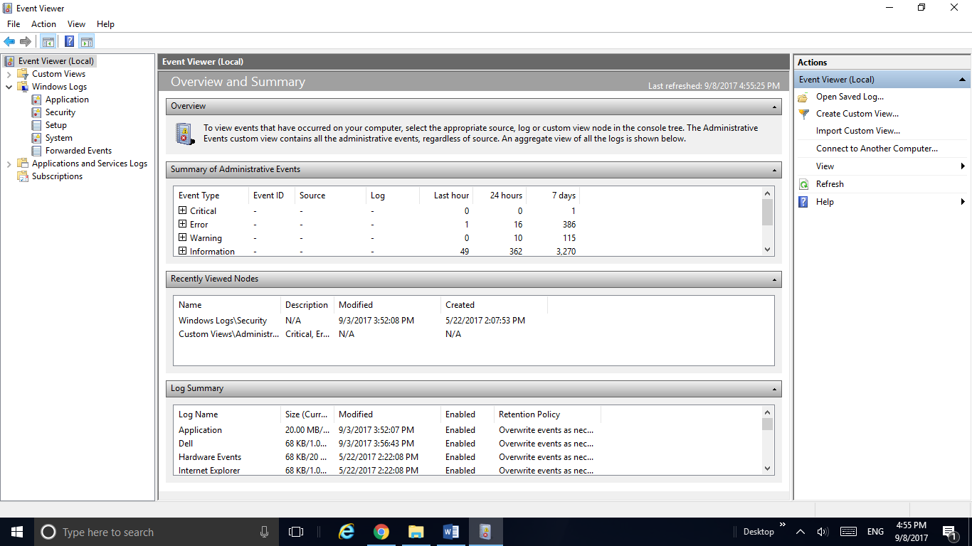

Fig. 1. Screenshot of Overview and Summary Page after close the detailed information of a specific event.